BINGO SAMPLE SCREENS

1) Tagging Widget Sample (ref: delicious chrome plugin)

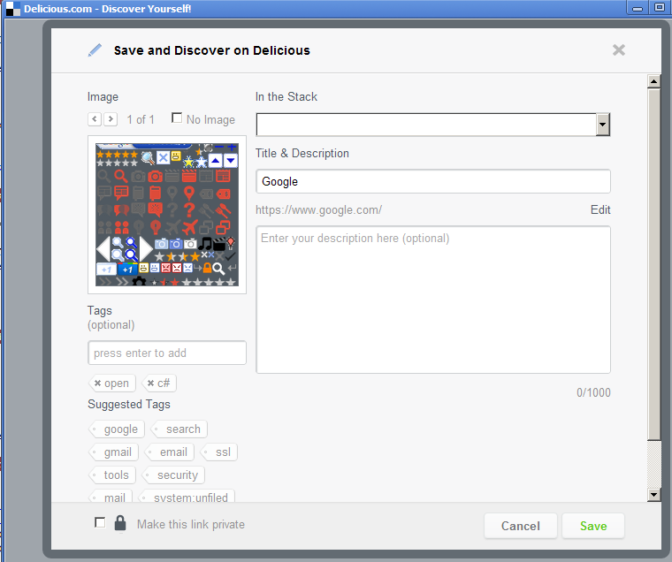

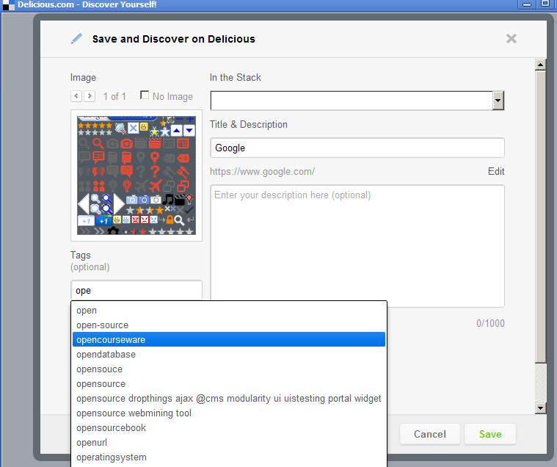
2) Badging Samples (ref: www.stackoverflow.com)

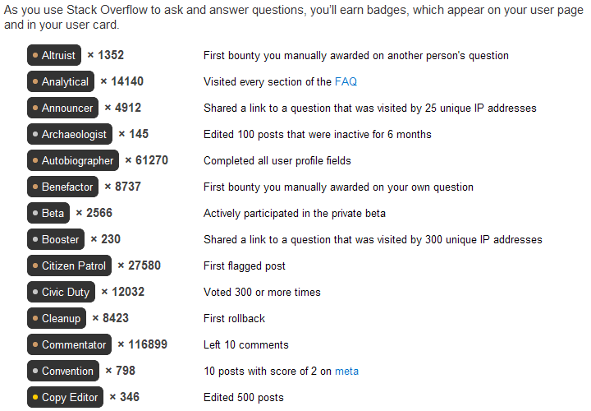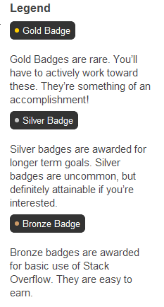

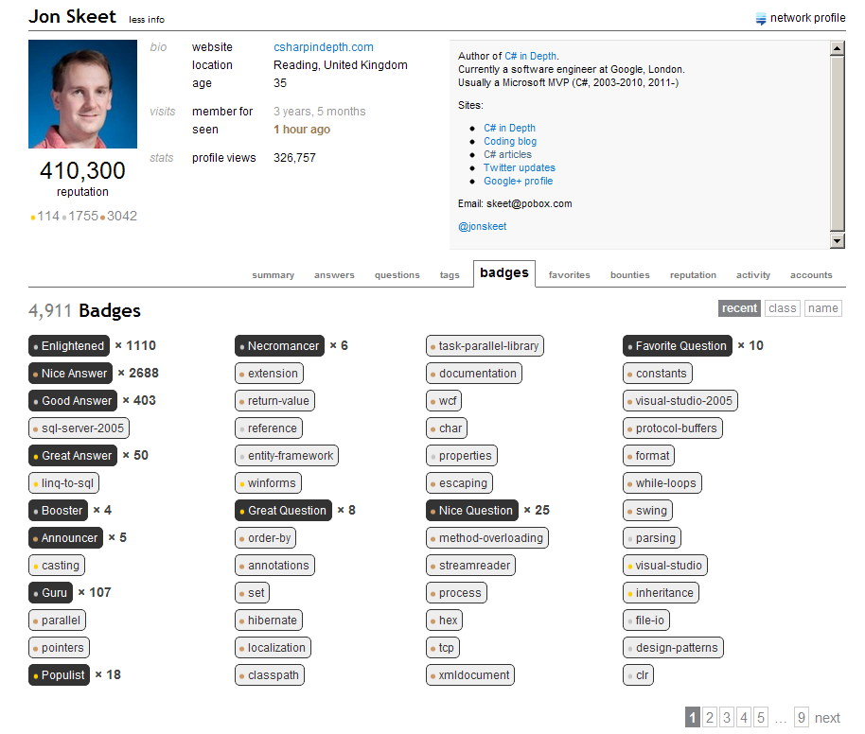

3) Tag Listing Samples (ref: www.stackoverflow.com)
